|  |
| --- |
| Big Mountain Resort |
|  |

|  |  |
| --- | --- |
| 11/01/2020 | Guided Capstone Project Report |

By,

Abhiram Muktineni (abhiram540@gmail.com)

Big Mountain Resort

Guided Capstone Project Report

# INTRODUCTion

Based on the dataset provided ‘ski_resort_data.csv’, consisting of market data from 330 Big Mountain Resort’s closest competitors across the US which suggests that the current day pass ticket price is under-priced, we built a model using Random Forest regression technique for predicting the ticket price of the Big Mountain Resort in order to offset the recent increase in operating costs of $1.54M and also increase profitability. Our model revealed that the current market will bear price increases from $81 to $94.22 (+/- $10.39). This would lead to an annual revenue increase between $4.952M ($2.83/day/ticket) and $41.317M ($23.61/day/ticket) assuming 350,000 customers purchased 5 day passes.

# Features

Of all the features modelled in the study, there were key features that came up as important in modelling and impacted the ticket prices the most: Fast Quads, Runs, Snow-Making and Vertical Drop. We used these features as the basis for analysis for capital investment and recommendations for next steps.

# Recommendations

Recommendations for next steps can be classified into ‘Immediate’ and ‘Short Term’

## Immediate Recommendations:

1. Increase the ticket price to the minimum recommended by the study, from current $81 to $83.83 per day per ticket. On a daily basis a revenue increase of 2.3%(83.83/81) should result and could be validated against recent sales info.
2. Eventually increase the ticket price to a maximum of $104.61 based on the positive results obtained above.
3. Close one run from current runs available by selecting the least travelled or least popular run. This should not impact the results predicted in the above steps. The below model says there would be no impact in revenue for closing one least popular run. However, closing multiple runs successively reduces support for ticket price and so revenue resulting into a loss. You can consider operating this run only when there is an increase in demand. Meanwhile, the operating costs saved during off days can be added to the resort’s savings.

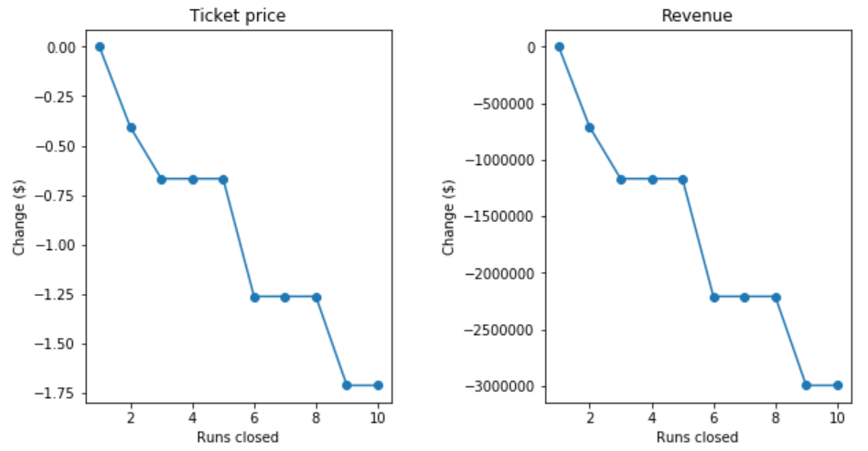

## Short Term Recommendations:

1. As described above some of the key features which had great impact on the ticket price were Runs, Snow Making and Vertical Drop. Based on our model, adding a run, increasing the vertical drop by 150 feet, and installing an additional chair lift increases support for ticket price by $1.99 this in turn could lead to an increase in revenue by about $3.48M per season. These additions justify and offset the $1.54M increase in resort’s operational cost and brings in profit of $1.94M above that amount.
2. Adding 2 acres of snow making to the above changes will make no difference, still leaving increase in ticket price by $1.99 and annual revenue increase to $3.48M. But, adding more snow making might attract a few more visitors which might eventually increase the overall revenue.